* Visualize portland (Schools - School Districts - Highways)

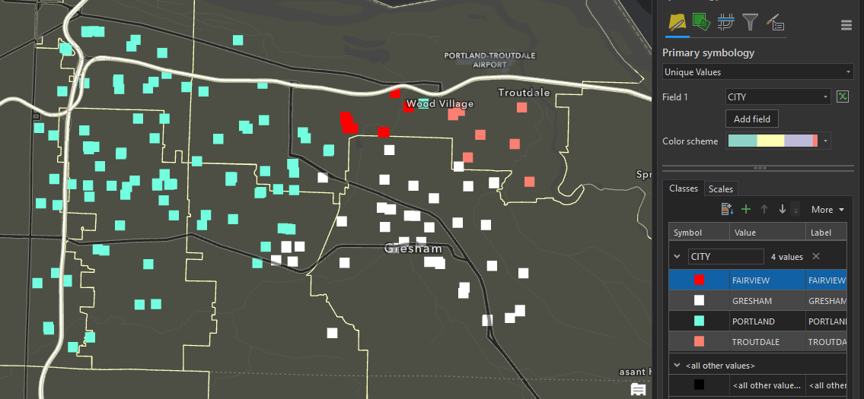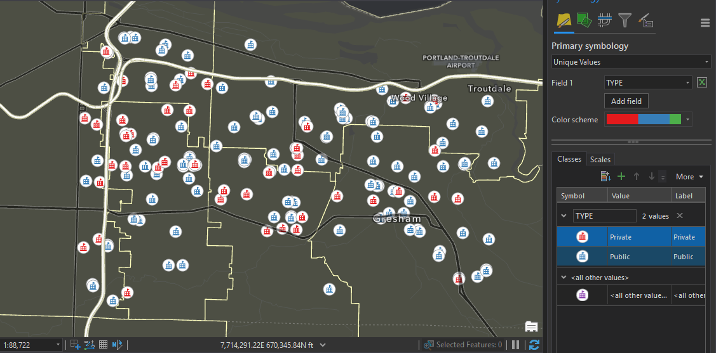

* Visualize Peaks in yellowstone ⇒ (elev-ft)

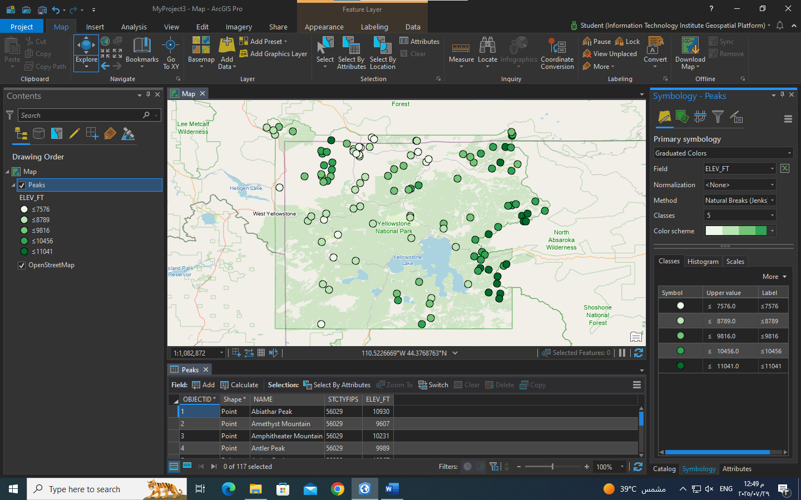

* Diabetes - Obesity ⇒ Bivriate Colors

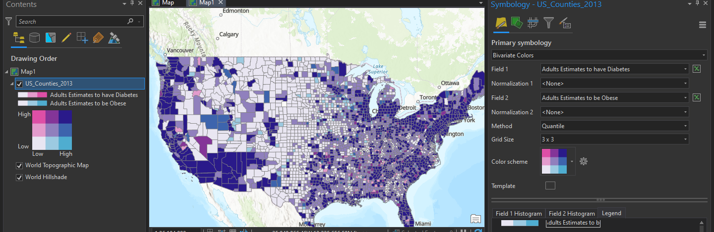

USA Census ⇒ Normalization

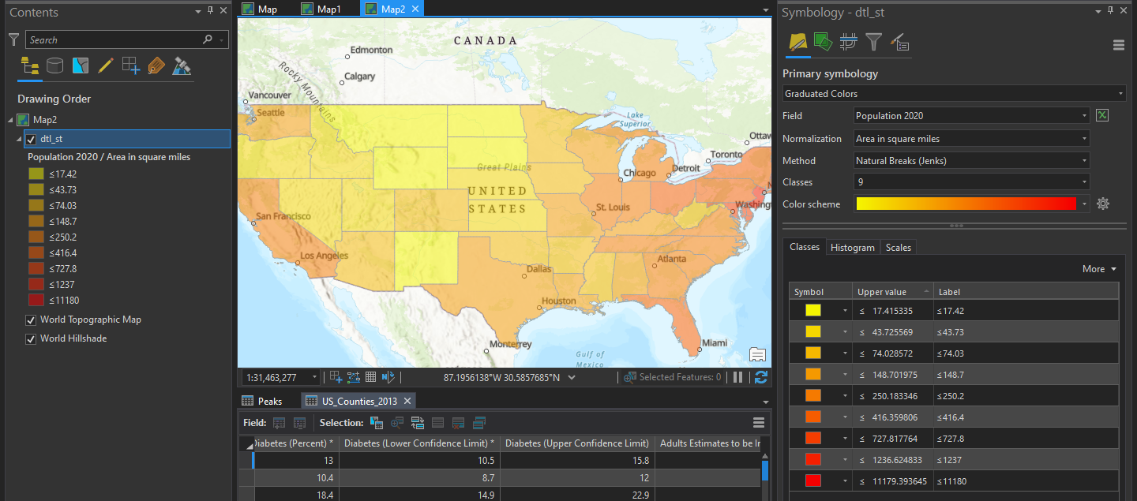

1. Data Aggregation ⇒ Sanfransisco

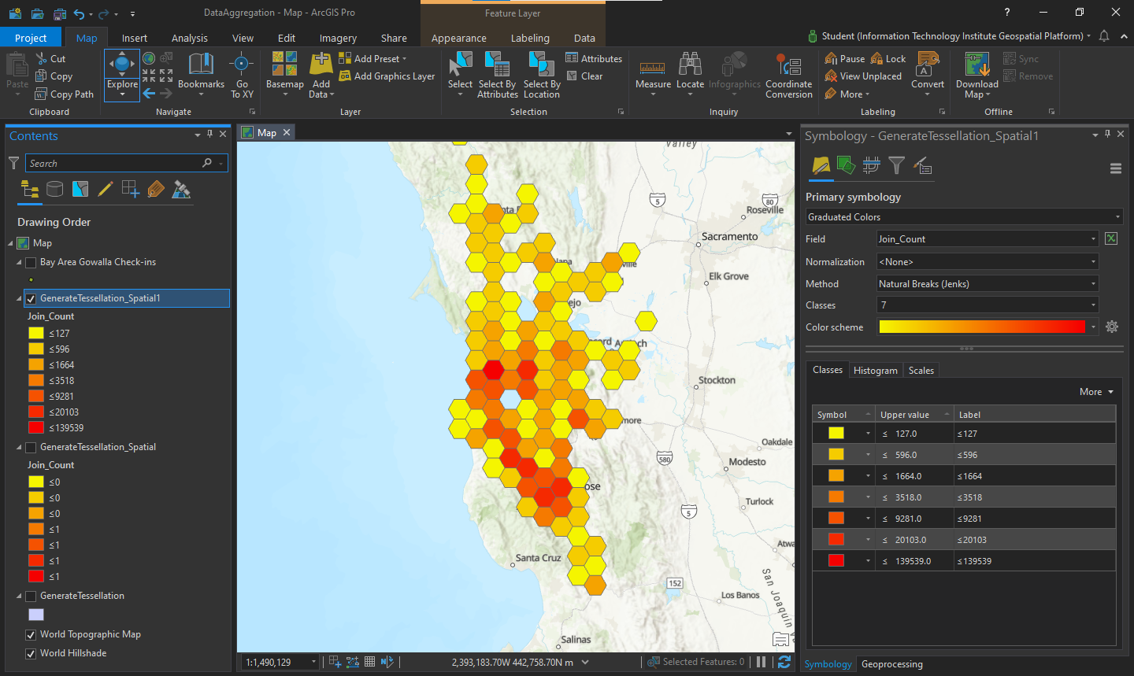

Crimes Data

